Name
Instructors Name
Course
Date
Biodiesel Lab Report
Introduction
Background
Made from biological sources, biodiesel offers cleaner burning renewable alternative to diesel fuel (Demirbas 196). When mixed with diesel, it can be burned in unmodified diesel engine at nay concentration. The fuel is made through a process known as transesterification process. Transesterification is the process where one ester is changed into another (Make-Biodiesel n.p) Chemical laboratory makes biodiesels by mixing an ester compound like vegetable oil and alcoholic compound like methanol. During the reaction, the fatty acids of the triglyceride contained in the vegetable oil and animal fats, molecule are cleaved and attach to the alkyl group of the alcoholic compound, methanol to form fatty acid alkyl esters, which are biodiesel (Chevreul 234).
KOH + FFA H2O + [K+][-FFA](soap)
This reaction above shows the titration process, and how the base (KOH) reacts with the free fatty acid to produce water and soap. Phenolphthalein is used in titration process as an inductor of the reaction.
Vegetable oil + Methanol Biodiesel + Glycerol (KOH as a catalyst)
This chemical reaction appears when vegetable oil reacts with methanol to produce biodiesel and glycerol, that reaction happen with the presence of KOH as a catalyst. The reaction occurs at a temperature of 60⁰C.
Purpose
This experiment was intended to change vegetable oil into biodiesel. Utilizing clean vegetable oil costs as much as conventional diesel. Consequently, this test designed to utilize squander vegetable oil, as it's more moderate, and attempt to shape it to get biodiesel that can be utilized.
Equipment
Equipment used for this reaction included
- Burette
- 100ml volumetric flask
- hot plate
- Separatory funnel
- Test Tubes
Reagents
- KOH base
- Isopropanol
- Methanol
- Phenolphthalein
- Sodium Chloride
- Glycerol
Procedure
Standard Convention
Setting standard convention is critical for any experiment. Therefore, the group set a standard convention to follow when creating the biodiesel. Since running many reactions would have taken much time, the class was divided into many groups, each group running a response with a specific goal (Demirbas 196). The chosen reaction for this group was to add 5 minutes. After running the reaction, it was determined that adding more time was not the most effective way to get the needed result. The outcome, however, demonstrated that the ideal result would be accomplished by including a more significant amount of the KOH base.
Titrating Stage
The goal of the titration stage was to measure the needed KOH. In this stage, a pellet of KOH was added to 100 mL of water in a volumetric flask for two stages of 50 ml each to allow the pallet to dissolve fully. Once it disappeared, the volumetric flask was filled with another 50 ml of water. Then burette was washed twice with a titrating solution and then filled with titrating solution. Later, the oil was set up by dissolving one mL of oil in 10 mL of isopropanol and a couple of drops of phenolphthalein (Demirbas 196). The volume of the arrangement was then recorded. Finally, the titration solution was added slowly to the mixture until the mixture turned red, and stayed for 30 seconds. Then the final volume was recorded. This stage was repeated four times to get the best results.
Synthesis Stage
The purpose of this stage was to separate glycerol and biodiesel. The first step was to heat 100 mL of waste oil until it reaches 60C, add 9.324 mL of methanol, and (4.9 plus titrating) KOH g per letter of oil to the oil. The mixture was then left for an hour to heat and spin at the same time using the hot plate. After that period was done, the mixture was left for a week to allow glycerol and biodiesel to separate.
Filtration and Testing Stage
The last stage was the filtration and testing stage. This stage followed a lab timeframe of two weeks from synthesis stage after which the mixture was ready for purification. At first, biodiesel was separated from glycerol by pouring it into another jar. 10 mL was then taken for tests with real crude biodiesel for comparison (Twmffat n.p). The rest of the biodiesel was washed five times using a separatory funnel. At this time my group was divided. One group did crude biodiesel testing while the rest of the group members did the washes.
Initially, the three tests on the crude biodiesel were 3-27 tests, emulsion test, and the point cloud test. 3-27. These tests were done by adding 9mL of methanol for 1mL of biodiesel. Emulsion test was adding several milliliters of crude biodiesel with the same amount of water. Point cloud test was done by putting five mL of biodiesel in an ice bucket until the oil started to be cloudy. The washes, on the other hand, were done five times. The first one was done using water producing a big bubble in the water and the biodiesel. Although the second wash used water as well, it was clearer than the previous wash. The third wash used aced as the washer producing much cleaner results. Just like the first and the second, the fourth wash used water, and the biodiesel looked almost clear. Since the biodiesel contained some remaining soap, the last wash used acetic acid, but nothing changed. Thus, Sodium Chloride was added, and it helped purified the biodiesel
The experiment took four days. The first day was to contrast waste vegetable oil to clean vegetable oil, so each group attempted different method, and it was determined that the best outcomes were gotten by including baser. The Second day followed lab time frame on determining the amount of needed base. In the third day, the combination was finished. Oil was added to methanol and the base, and if we left that in the lab for a week so the biodiesel can be purified. Finally, the biodiesel was purified, and three tests were run to a crude sample and purified biodiesel.
Data and Results:
Day1 Observation
The goal of this day was to figure out which conditions would create the most biodiesel. Thus, the class was divided into many groups each testing clean and waste vegetable oil to determine the best result. The results showed that the possible biodiesel from clean vegetable oil could be produced by; doubling NeOH, decreasing the temperature, or adding more time. Similarly, the most biodiesel was produce by increasing the value of KOH. Therefore, we multiplied 0.124 g of KOH by 1 L of oil, divide that by 4.9 g and got 0.025L. Converted to ml, it produced 25.306ml. Consequently, the result for day one was 95% of clean veg oil, obvious, and slightly yellow. For the waste veg oil, we got 15% that was clear, but darker yellow as shown in the figure1 below.
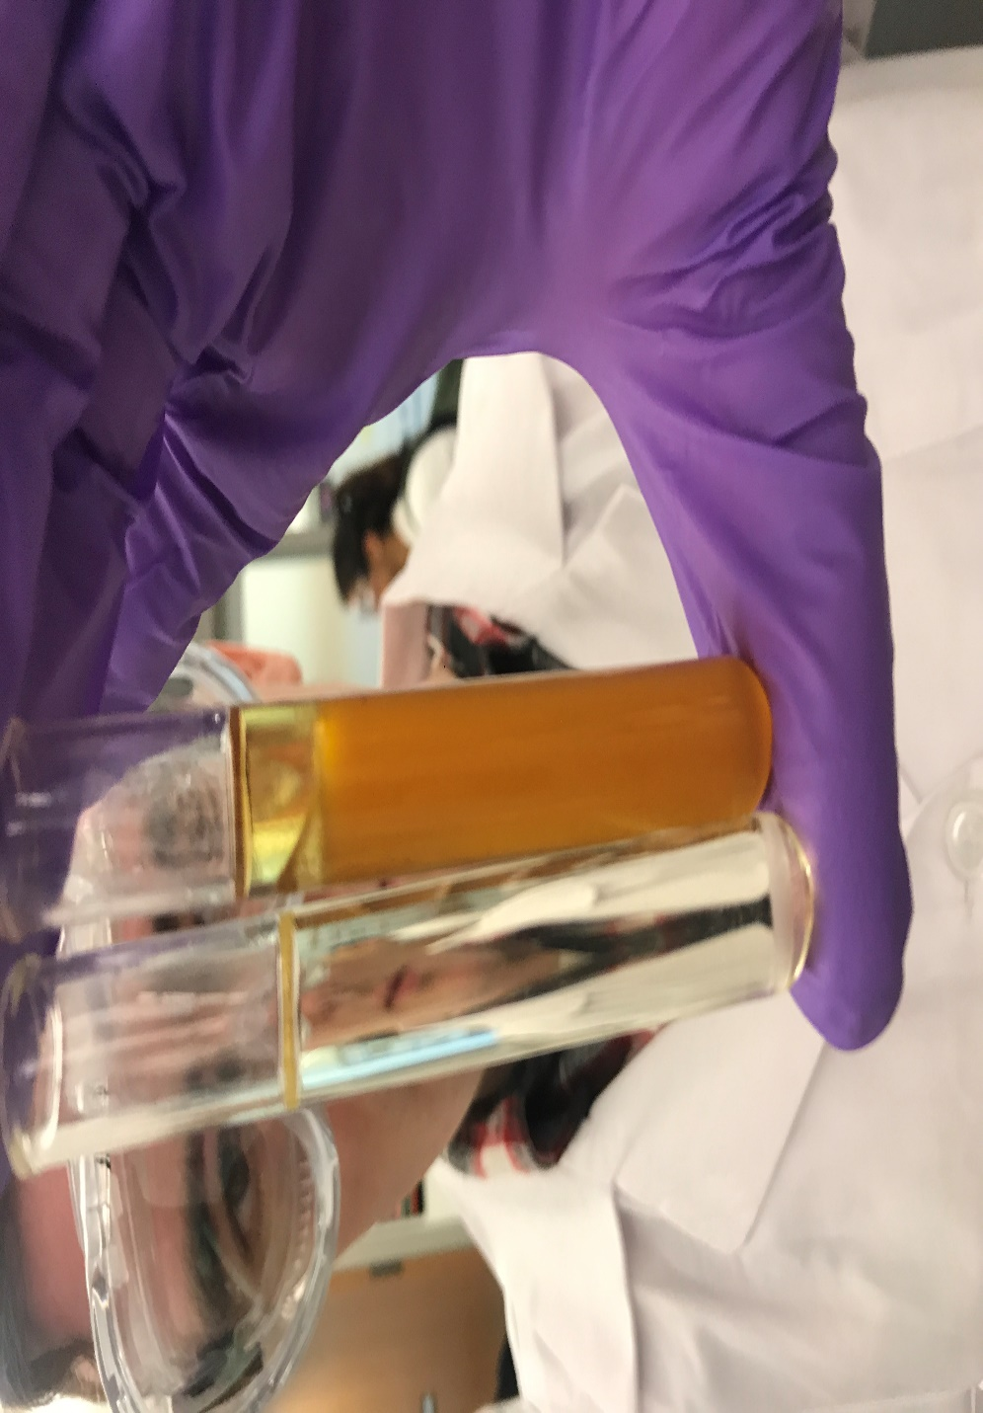
Figure 1: Showing the clear and yellow waste veg oil
Day two:
The aim of this day was to determine how much KOH we needed for the adding to the free fatty acid solution. The burette was washed with 5.2mL of titrating solution; then the titrating solution was added 100 ml volumetric flask. The group made five attempts, and the results were 11.2mL, 8.6ml, 8ml, 7.5ml, and 7.8ml respectively. Because of the gap between the first attempt and the rest, the average attempt was taken considering the last five tries. After doing the average, 62ml, we used 100 of oil as shown in the equation below:

$\frac{grams of KOH}{100m titrating sol}*\frac{mL titration solution used}{1mL of oil}*\frac{1000mL of oil}{\begin{aligned}\left( of oil\right) \\ \end{aligned}}=\frac{grams of KOH}{L of oil}$
So we had
$$\frac{0.12 g of KOH}{100m titrating sol}*\frac{7.77 mL }{1mL of oil}*\frac{1000mL of oil}{\begin{aligned}\left(1 L of oil\right) \\ \end{aligned}}=\frac{9.324 KOH}{L of oil}$$
Day 3
The data collected in the previous lab period was used during this day. The used volumes in this lab were 100mL of oil, 22ml of methanol (22% of the oil, and 1.4261g of KOH). The mixture was then left for an hour to heat and spin. It looked like a two-layered solution, the top layer was biodiesel, and the bottom layer was glycerol.
Day 4
During this day, three tests were run, three for crude biodiesel and three for clean biodiesel. The tests were 3-27, emulsion test, and cloud point. The results of the crude’s tests were: for 3-27 (5 %) of which is veg. Oil Emulsion – the presence of soup at the bottom of test tube test, and for the cloud point test the biodiesel because cloudy at 7.5C. and for the clean test, 3-27 visible but small increase in oil, maybe 8-9%. The emulsion was very clear and visible separation as shown in figure 2 below while Cloud point – 2 c is shown in figure 3.
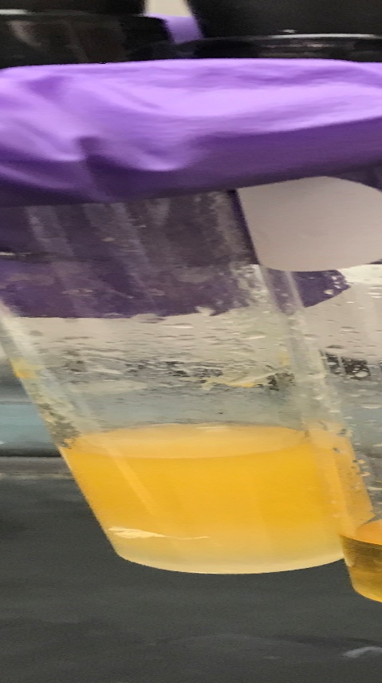
Figure 2: Emulsion test crude biodiesel.
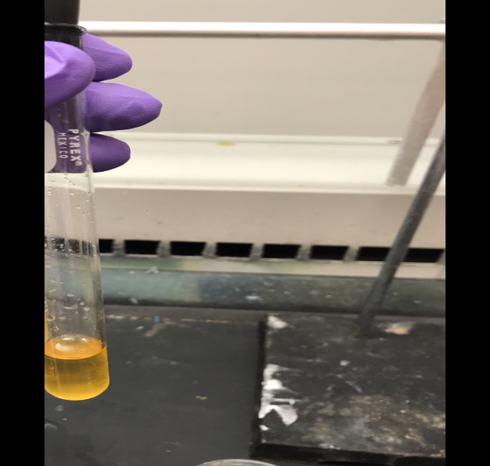
Figure 3: cloud point test crude biodiesel.

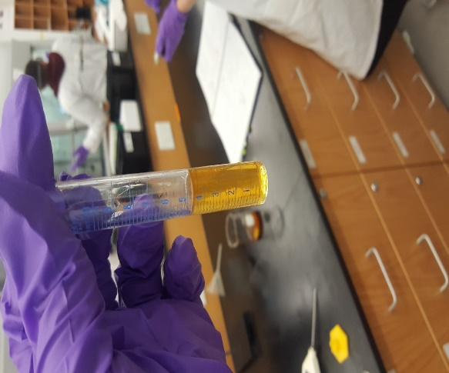
Figure 4: Cloud point test clean biodiesel.
Discussion
The team successfully made biodiesel out of waste vegetable oil. The final result came as expected. On day one the conditions that the team used did reach the expected goal. However, while the results of the rest of our group wanted 95% of biodiesel of clean veg and we only got 15% of biodiesel of wasted oil. On the second day, the group did five tests, which was to be used in calculating KOH. The average percentage of the FFA was 15.108. Although many tests occurred as planned on the third day, the groups turn off the hot plate when the blend was on the hot plate, and it was just turning (Demirbas 196). However, when the mixture was left for two weeks rather than one the mixture was looking as needed. On the last day when the group did the first was, the solution was good, so the team used acetic acid instead of water for the third washes. In general, the team successfully achieved the goal.
On the second day after the team calculated the excess KOH, the percentage of the free fatty acids (FFA) was calculated, and it came out to be 15.108%. This result was shown when the team did the emulsion test on the fourth day. When the test was done on the crude biodiesel, the result was little soapy, which represent free fatty acid. However, after the five washes, the biodiesel was very clear.
On the fourth day 3:27 test was done twice, once with crude biodiesel and one with clean. The result of that showed that the crude biodiesel had 5% of which is veg oil. On the other hand, the result of the clean biodiesel showed that the solution contained 9-8%. Although the two solutions had the same starting amount of biodiesel, the results of the could-point tests showed that the biodiesel is ready for cold weather (Demirbas 196). Both biodiesels clean and crude started to be foggy at very low temperatures, 2 C for clean biodiesel and 7.5 C for crude biodiesel. From that, it could be determined that the biodiesel is ready to be used in cold weather.

Works Cited
"How to Make Biodiesel At Home". Make-Biodiesel.Org, 2018, http://www.make-biodiesel.org/. Accessed 10 Apr 2018.
Chevreul, Michel Eugène, and Albert J. Dijkstra. A chemical study of oils and fats of animal origin. Sàrl Dijkstra-Tucker, 2009.
Demirbas, Ayhan. "The biodiesel economy and biodiesel policy." Biodiesel: A Realistic Fuel Alternative for Diesel Engines (2008): 195-204.doi:10.1007/978-1-84628-995-8_10.
Twmffat, Tecwyn. "Titrating Waste Vegetable Oil For Biodiesel Production". Instructables.Com, 2018, http://www.instructables.com/id/Titrating-Waste-Vegetable-Oil-for-Biodiesel-Produc/. Accessed 10 Apr 2018.

